Roasted Vegetables with Caribbean Dressing

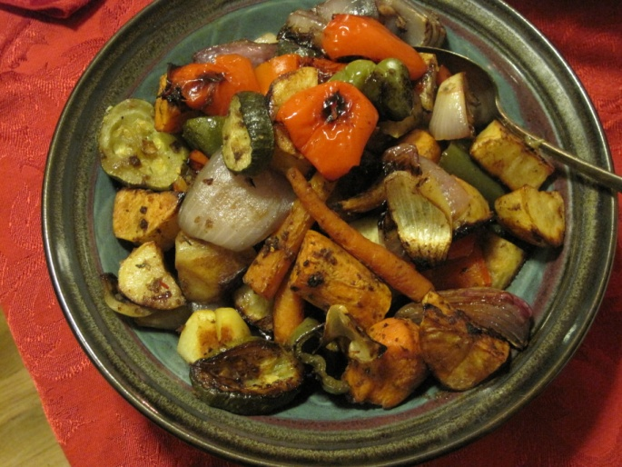

2 potatoes, cut into 1-inch chunks or cut in half lengthwise and sliced crosswise into ½ inch thick semicircles
2 sweet potatoes, peeled and cut into 1 inch chunks
2 carrots, peeled and cut into 1 inch chunks or cut on the diagonal into ½ inch thick slices
1 large onion, cut into wedges
1 medium zucchini, cut into 1 inch chunks or cut on the diagonal into ½ inch thick slices
2 bell peppers, cut into 1 inch chunks (two different colors is nice)

Caribbean Dressing
3 tablespoons soy sauce
1 tablespoon canola or other vegetable oil
2 tablespoons red wine vinegar
1 tablespoon packed brown sugar
1 small onion, coarsely chopped
½ teaspoon dried thyme
½ teaspoon ground cinnamon
½ teaspoon ground cloves
½ teaspoon ground black pepper
2 teaspoons grated fresh ginger root
1 large garlic clove, minced or pressed
1 fresh green chile, coarsely chopped, seeds removed for a milder "hot"

Preheat oven to 425 degrees.
Parboil the potatoes, sweet potatoes, and carrots in boiling water to cover for 2 minutes. Drain well. In a large bowl, combine the parboiled vegetables with the onions, zucchini, and bell peppers.
To make the dressing of your choice, either whisk together the ingredients in a bowl, or puree them until smooth in a blender or food processor.
Toss the vegetables well with the dressing. Place the vegetables in a single layer on a large unoiled baking tray and bake, stirring every 15 minutes, until all of the vegetables are ender, about 45 minutes.
To roast without parboiling: bake the vegetables in sequence. Prepare a large baking tray with cooking spray or a light coating of oil. Place the white potatoes and carrots on the tray and bake for 15 minutes. Add the sweet potatoes and bake for another 15 minutes.
Remove the vegetables from the oven and transfer to a large bowl. Add the onions, zucchini, and bell peppers to the bowl and toss with the dressing of your choice. Spread the vegetables on the baking tray in a single layer and return to the oven. Bake until all of the vegetables are tender, about 45 minutes, stirring occasionally to prevent sticking.

Other dressings:

Italian Dressing: Cantonese Dressing:
4 teaspoons olive oil 1/3 cup soy sauce
¼ cup fresh lemon juice 1/3 cup rice vinegar
6 garlic cloves, minced or pressed 1 tablespoon grated fresh ginger root
3 tablespoons minced fresh rosemary 1 tablespoon honey
(2-3 teaspoons dried and ground) 1 tablespoon dark sesame oil
1 tablespoon minced fresh oregano 3 garlic cloves, minced or pressed
1 teaspoon salt ½ teaspoon ground anise

