A COMPREHENSIVE Guide TO Finding Peer-Reviewed Sources

Overview for GEOG 300:
- In the Analysis section of your CT papers, you must cite at least 4 relevant sources that are peer-reviewed and from the last 10 years (2007-2017). Failing to do this will result in a zero on your CT paper.
- You may use other sources that do not meet this criterion (non-peer reviewed sources, or sources published before 2007), but only in addition to the four required primary sources.
    - There is no need to distinguish between peer-reviewed and non-peer-reviewed sources within your Bibliography. If you list your references in a proper format, then we will be able to tell the difference between them.

What does “peer-reviewed” mean???
- Peer-reviewed publications are written by experts and are reviewed by several other experts in the field before the publication is published; this is done to ensure the article’s quality. For this reason, such publications are more likely to be scientifically valid, reach verifiable conclusions, etc. In most cases the reviewers do not know who the author of the article is, so that the article succeeds or fails on its own merit, not the reputation of the expert” (ASU Library Services 2017).
  - In other words: using peer-reviewed publications ensures you that the information you cite from that publication is legitimate, accurate, and (as much as possible) unbiased.

What classifies as a peer-reviewed publication?
- Articles from peer-reviewed (or scholarly) journals. For more information on this, check out this link: Differences between Scholarly Journals, Popular Magazines & Trade Publications
- Books (or text-books) may or may not count as peer-reviewed publications, this depends on the publisher of the book. Some publishers require that the content of the books they publish is reviewed by a board of scholarly reviewers in the subject area of the book, as some don't require this at all. However, in this class all books will be considered peer-reviewed sources.

What does NOT classify as a peer-reviewed source?
- "Newspapers and magazines. Articles are written by reporters who may or may not be experts in the field of the article. Consequently, articles may contain incorrect information" (ASU Library Services 2017).
- "Journals containing articles written by academics and/or professionals. Although the articles are written by “experts,” any particular “expert” may have some ideas that are really “out there!” (ASU Library Services 2017).
  - {Examples: National Geographic, New York Times, The Economist, etc.}
- Websites. It does not matter if the website ends in .com, .org, .gov, .whatever – information on websites is not peer-reviewed. It may be fact-checked and reliable information, but it does not mean it underwent the peer-reviewed process. The information could be coming from a prestigious NGO (ex: WWF, GreenPeace, Survival International, etc), and it may be highly accurate, but it does not mean it is peer-reviewed.
- Dissertations, theses, industry reports, NGO reports. These types of sources are often referred to as "grey literature." Again, these documents could contain valuable and reliable information, but they do not undergo the peer-reviewed process.
- Blogs. Some prestigious scholars might be great bloggers but blogs are not peer-reviewed. You can get ideas and inspirations from these, but do not cite them in a scholarly paper.
- Government reports or publications. These could be peer-reviewed, but this is not always the case and it varies by country. For this reason, it’s best to not assume that they are not.
VERY IMPORTANT: You need to cite a minimum of four peer-reviewed sources as primary sources with the Analysis section of your CT paper – from the categories listed in green above – to avoid receiving a zero. You can cite sources that fall within the categories listed in red above, but these can only be used as secondary sources, and in addition to the four primary sources.

How to Find Peer-Reviewed Journal Articles through the OSU Library Website
This is how the OSU Library explains how to identify a peer-reviewed journal: "Peer-reviewed journals can be identified in several different ways: (1) Journals identify themselves as peer-reviewed (in the small print describing who they are in each issue, or on the publisher's website about the journal). (2) You can also do a search in several databases such as Academic Search Premier and limit your results to "Scholarly" or "peer-reviewed." [If using this search engine, note that we ONLY accept articles that appear in EBSCO supported databases with “peer-reviewed” button checked.]
To do this:
- Go to http://osulibrary.oregonstate.edu/
- Type some key words related to the topic you’re researching.
  - It helps to play around with this, as you will get different results if you change some of these words. For example, you can type “sustainability of electric cars”, then try something like “benefits of electric vehicles”, or “disadvantages of electric cars”, etc.
- IMPORTANT: Once you are on the page showing the results of your search, make sure you click on “Peer-reviewed Journals”, located to the left, under “Show only” (as shown by the red arrow below)
  - This will ensure that you only look through sources that classify as ‘peer-reviewed’

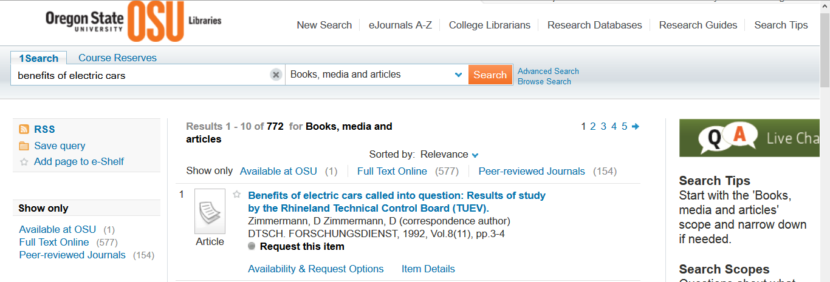

Alternative Search Engines
You can use other search engines and databases if you wish. Google Scholar is a popularly used tool for finding peer-reviewed journal articles, but you must be careful when using it, as this database is not as clear about the quality of the results from your search (as the OSU Library website can be). If you are not sure you can tell the whether a source you found though Google Scholar is peer-reviewed, then do not use as a primary source or double check that it is before doing so.
If you’re not certain whether a source you want to use is peer-reviewed or not, please contact your T.A. and have them approve (or disapprove) of the source before you submit your CT paper.

